SkillShow, portfolio tool for showcasing computer science projects and skills.

Team Dingo

Chauncey O'Connell

Josh VanSantvoord

Mason Peasley

Nathaniel Hayes

Xander Watkins

# Problem

Students often struggle to effectively share and showcase their coding work, particularly when it comes to displaying project overviews rather than just the underlying code. This problem is exacerbated by many employers utilizing generative AI, limiting the number of entry-level job opportunities being offered to junior engineers entering the workforce. If new graduates could demonstrate their ability to effectively use generative AI to boost their productivity and enhance their skillsets, then they might be more likely to be hired into a traditional junior role. Standard solutions like GitHub have been widely adopted in computer science education and offer tools for code documentation, version control, and collaboration. However, they lack options to create polished, professional portfolios that can effectively demonstrate a student's capabilities to potential employers. In addition, there is currently no standard way to demonstrate a students’ ability to efficiently and effectively use generative AI. How can we create a way for students to better showcase the coding work they've accomplished in an organized and professional manner that also demonstrates generative AI proficiency, while taking into account the widespread academic adoption of GitHub?

# Prior Solutions

## Solution 1: Github

Overview of Solution:

GitHub is a cloud-based platform designed for developers to collaborate on code, manage software projects, and track version control using Git. As an app, GitHub allows users to view repositories, manage issues and pull requests, review code, and stay connected to development activity from anywhere. It makes collaboration and in-app code review easy. Github allows users to Star repositories as a quicker way of accessing them from the user’s list of repos. Users not associated with projects may also “star” repos to watch the project’s progress.

SkillShow will enable users’ to import information from their existing GitHub repositories to show a detailed overview of the users’ work, as well as allow users to view and share their work through links. SkillShow will allow users to customize how their portfolio is displayed, giving them more control over how potential employers view it. While Github serves as a good option for viewing code on a project level, SkillShow will focus on connecting new graduates with potential employers by showcasing their different technical skills derived from their portfolio. This includes project overviews, demonstrations, and any skillset that the user wants to highlight, such as AI proficiency. This approach will create an easier way for students to start curating a more professional portfolio to showcase their coding ability, which will improve students’ ability to stand out to employers right out of university.

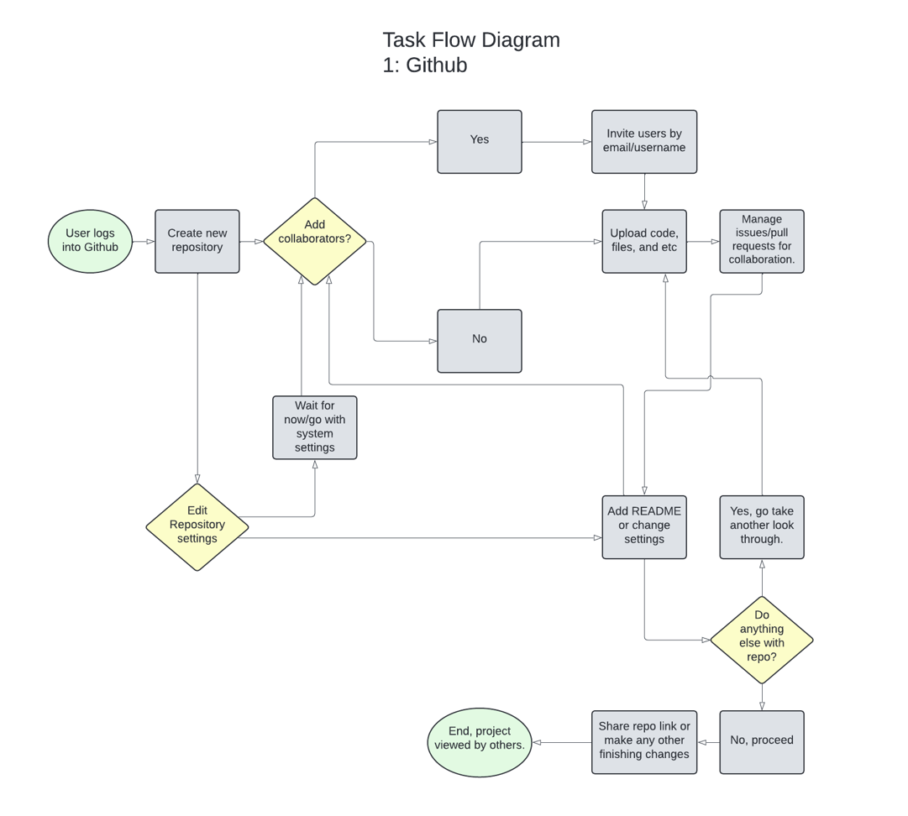

## Link: [Lucidchart document](https://lucid.app/lucidchart/d071590d-eea3-49ce-ad2c-0a88b7424200/edit?viewport_loc=-3366%2C-4646%2C3378%2C1925%2C0_0&invitationId=inv_fe9884eb-4746-42f8-bab3-881724d54e16)

## Solution 2: ArtStation

Overview of Solution:

ArtStation is a digital platform designed for artists to showcase their portfolios, discover creative work, and connect with other artists. ArtStation allows users to upload high-quality images, 3D models, animations, and more to professionally present their work. Through the app, artists can follow others, get inspired by trending projects, and even apply for jobs or sell prints and digital assets. It serves as both a networking hub and a marketplace. This makes it extremely valuable for both aspiring and professional artists to build visibility and advance their careers. The platform allows users to create high quality presentations that combine visuals, process breakdowns, and descriptions, giving viewers a complete picture of each project.

Similar to ArtStation, SkillShow will be a digital platform designed to showcase portfolios of work. There is some overlap between these platforms, as they both strive to provide a way for aspiring professionals in their respective industries to connect with potential employers. SkillShow is geared towards connecting computer science students and employers , while ArtStation serves as a marketplace for artists. In addition, users of SkillShow will be able to link their GitHub account to their profile for a more in-depth overview of their work, while ArtStation links to users’ social media accounts. Finally, SkillShow intends to highlight generative AI proficiency in students’ portfolios as a means to combat a narrowing job market. For example, SkillShow will allow users to annotate sections of their portfolio that were created or improved with generative AI. Although ArtStation does not ban generative AI, it does require users to tag anything as such when it is used, as it is not always accepted by the community. The focus on employer and student connection, and the focus on generative AI are critical differences that will serve as tools to help students break into the industry.

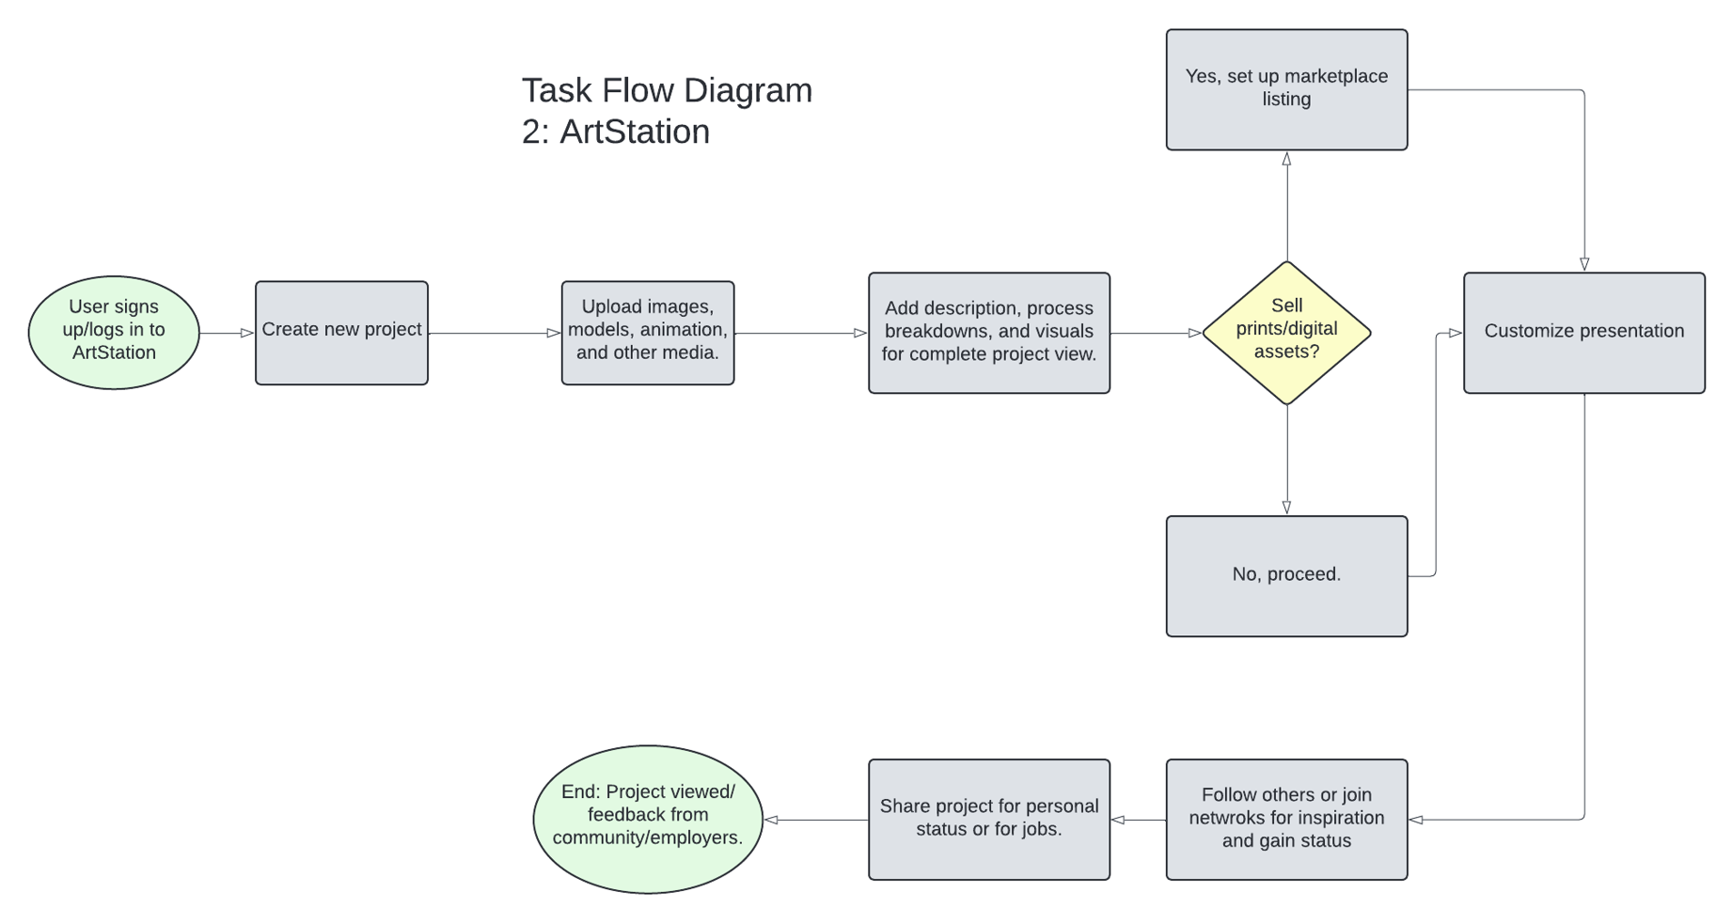

## Link: [Lucidchart document](https://lucid.app/lucidchart/d071590d-eea3-49ce-ad2c-0a88b7424200/edit?viewport_loc=-3366%2C-4646%2C3378%2C1925%2C0_0&invitationId=inv_fe9884eb-4746-42f8-bab3-881724d54e16)

## Solution 3: Behance

Overview of Solution:

Behance is a creative platform that allows the user to showcase their work, discover projects, and connect with other artists. Users can create professional portfolios, share visual projects across various disciplines such as graphic design, photography, illustration, UI/UX, and more. Behance allows the user to create a clean compilation of artistic work on the user’s personal page. Users can also receive feedback or appreciation from their peers. Behance also features curated galleries, job listings, and live streams, making it a good place for career growth.

Similar to Behance, SkillShow strives to allow users to curate a professional portfolio which showcases their abilities and skill sets. Both platforms allow other users to react to portfolios, allowing users to improve their profiles. One main difference is SkillShow provides a way for employers to filter based on needs, which will be tied to tags and skillsets listed by the student users. Additionally, SkillShow will allow users’ to import information from github and be focused on software and code. This feature allows for efficient student-employer matching. Employers can quickly narrow their search while students can showcase their strengths.

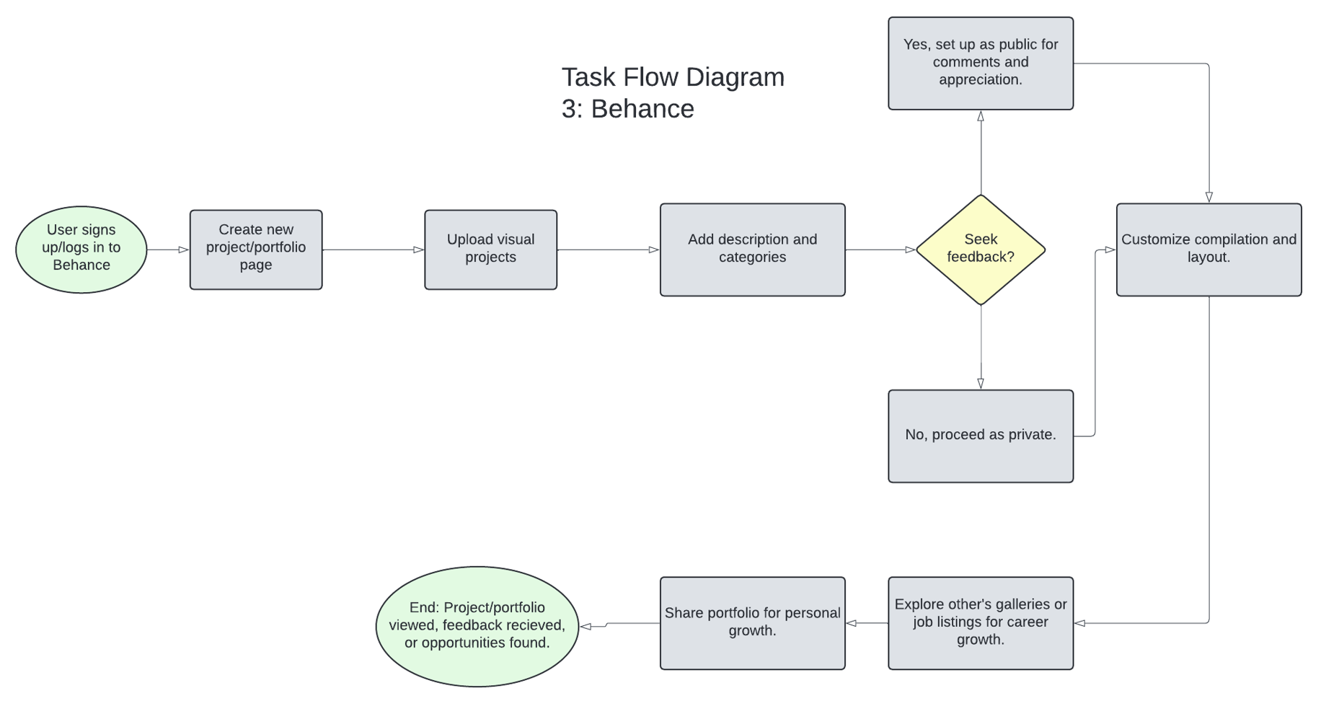

## Link: [Lucidchart document](https://lucid.app/lucidchart/d071590d-eea3-49ce-ad2c-0a88b7424200/edit?viewport_loc=-3366%2C-4646%2C3378%2C1925%2C0_0&invitationId=inv_fe9884eb-4746-42f8-bab3-881724d54e16)

# SkillShow

SkillShow is a digital portfolio platform that aims to help computer science students and graduates showcase their skills and connect with potential employers. SkillShow will allow for integration with users’ GitHub repositories to provide a more organized and customizable overview of their work. Users will be able to highlight specific projects, technical skills, and specialized areas such as AI proficiency, allowing them to create a portfolio that will showcase both their current strengths and future career goals. Additionally, users will be able to embed demonstrations of functional code or project snippets, allowing for employers to easily interact with users’ work directly. SkillShow will have an emphasis on professional presentation and community interaction, with a focus on allowing its users to connect with employers in the industry. Employers will be able to filter portfolios based on skills and tags, making it easier to find candidates that match their needs. The ultimate goal of SkillShow is to create a bridge between students and professional opportunities, allowing its users to stand out in a competitive job market.

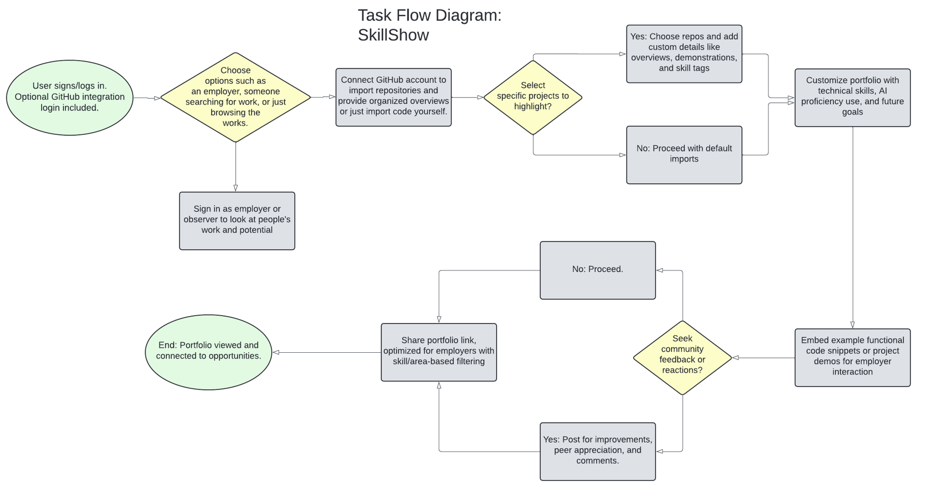

## Link: [Lucidchart document](https://lucid.app/lucidchart/d071590d-eea3-49ce-ad2c-0a88b7424200/edit?viewport_loc=-3366%2C-4646%2C3378%2C1925%2C0_0&invitationId=inv_fe9884eb-4746-42f8-bab3-881724d54e16)

